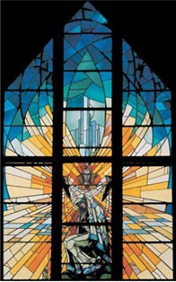

Our Lady of the Annunciation, Addiscombe
Parish Pastoral Council
Membership List (as at September 2023)

Fr Keith Fr Tomasz Jennifer Da Silva
Paul Donovan Nike Arowobusoye Terry Braim
Marie Tross Peter McGuigan Mary Ann McGuigan
Sarah Ellis Jenny Mitchener
Jessica Anne Mills (Parish Finance Officer)

Applications for membership welcome - especially from representatives of any of our parish groups.

If you wish to raise any matter with the PPC, please contact the parish office or speak to one of the members.

Parish Office: email: addiscombe@rcaos.org.uk
Tel: 020 8654 1709

